**Experiment No:**03

**Name of the experiment:** Simplification of Boolean function.

**Objectives:** To simplify the Boolean expression and to build the logic circuit. Given a Truth table derive the Boolean expressions and build the logic circuit to realize it.

**Components Required:** IC 7408, IC 7432, IC 7406

**Theory:** Canonical Forms (Normal Forms): Any Boolean function can be written in disjunctive norm form (sum of min-terms) or conjunctive normal form (product of max-terms). A Boolean function can be represented by a Kar-naugh map in which each cell corresponds to a min-term. The cells arranged in such a way that any two immediately adjacent cells correspond to two min-terms distance 1. There is more than one way to construct a map with this property.

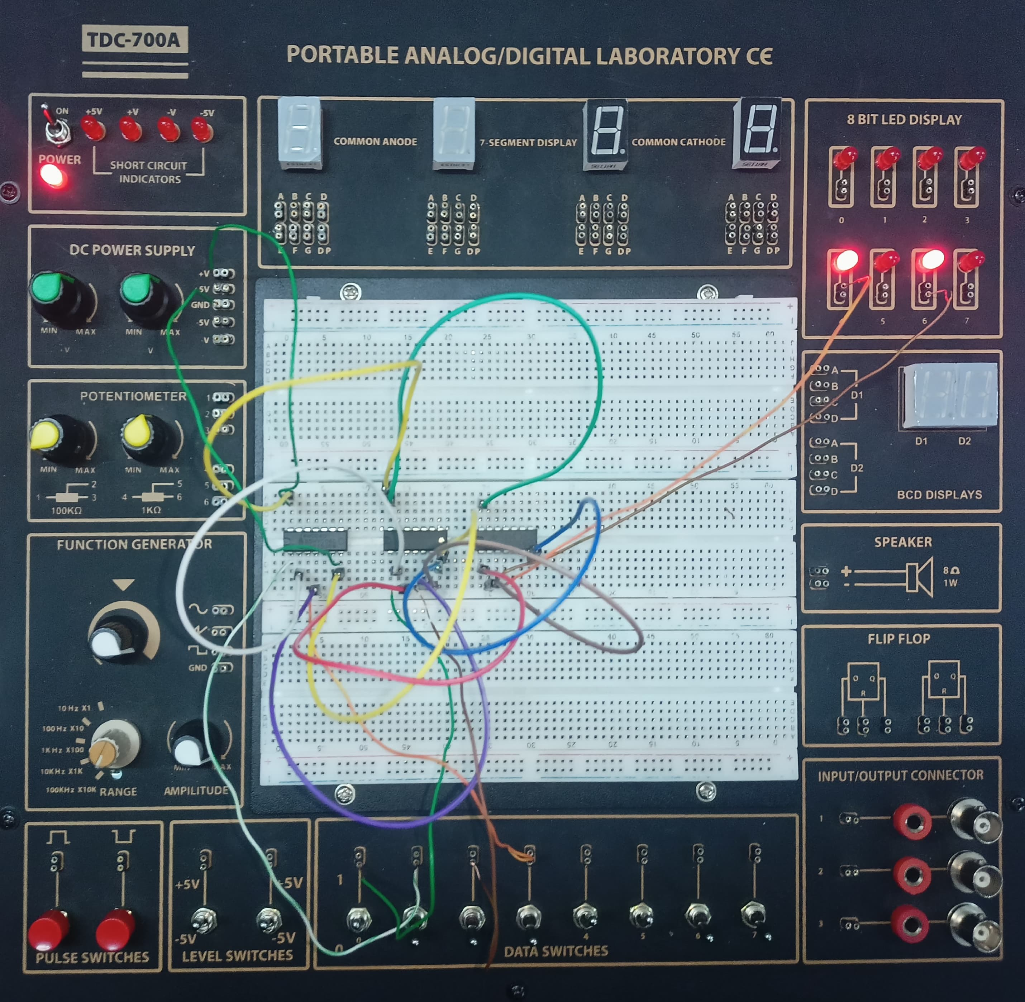

Fig: Completed Setup of Boolean Function

**Discussion:**

Upon completion of this experiment, there were a few topics learned. The first is how different Boolean Expressions can affect the outcome of a circuit. This lab also demonstrated that one can use Boolean Algebra to solve and predict the circuit outcomes. It is verified when the circuit is measured since the expected and predicted almost always are exactly the same.

There was some problem we faced in this experiment:

Wire have some problem and when we are taking inputs we get confused and got some error outputs.